Design and implement a Virtual Network in Azure
Resource Group: rg-Contoso
Virtual Network Name: | Address Space | Subnet Names: | Subnet Address Spaces: | Available Ips:
CoreServicesVnet | 10.20.0.0/16 | GatewaySubnet  SharedServicesSubnet  DatabaseSubnet  PublicWebServiceSubnet | 10.20.0.0/27  10.20.10.0/24  10.20.20.0/24  10.20.30.0/24 | Dynamicuse  251  251  251
ManufacturingVnet | 10.30.0.0/16 | ManufacturingSystemSubnet  SensorSubnet1  SensorSubnet2  SensorSubnet3 | 10.30.10.0/24  10.30.20.0/24  10.30.21.0/24  10.30.22.0/24 | 251  251  251  251
ResearchVnet | 10.40.0.0/16 | ResearchSystemSubnet | 10.40.0.0/24 | 251

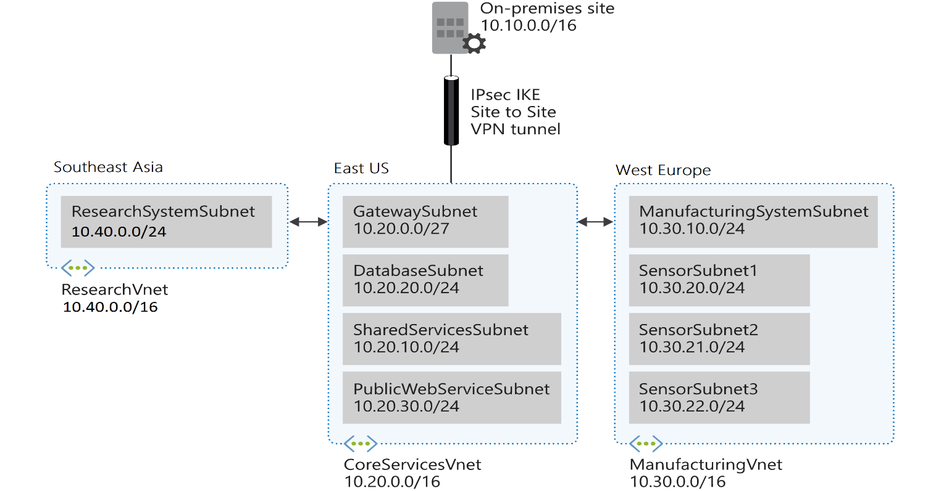
Technical Visual:
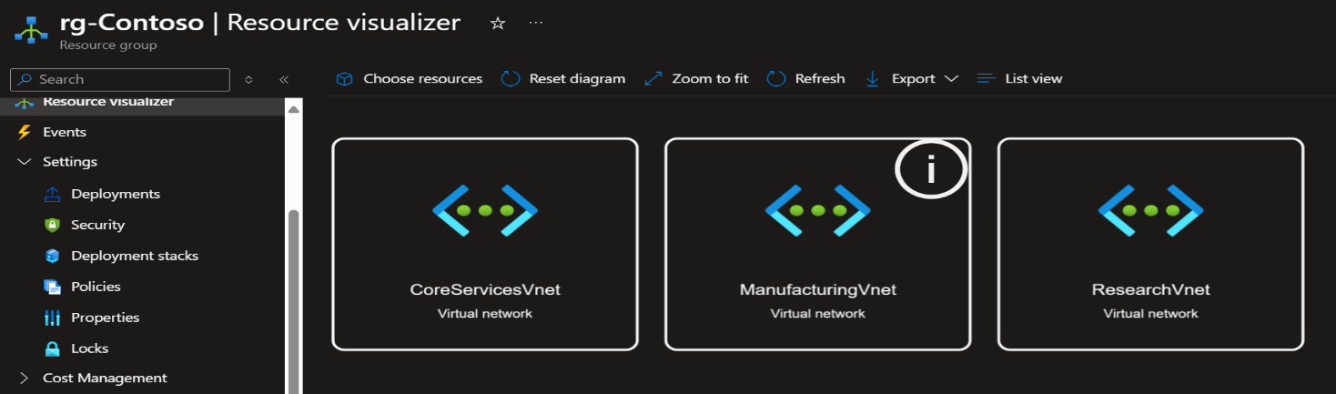

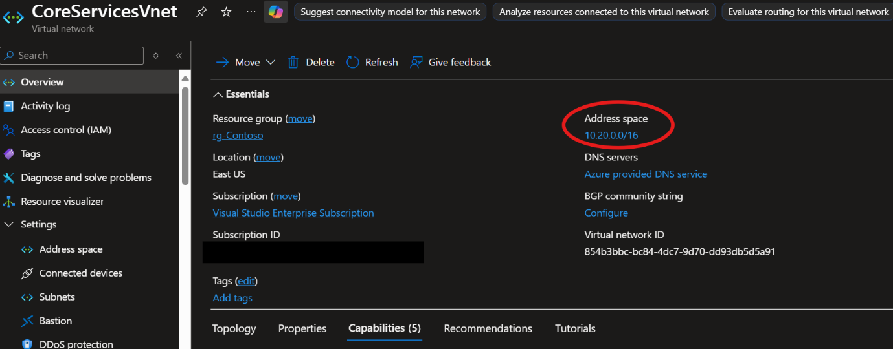
Figure 1: CoreServicesVnet Overview

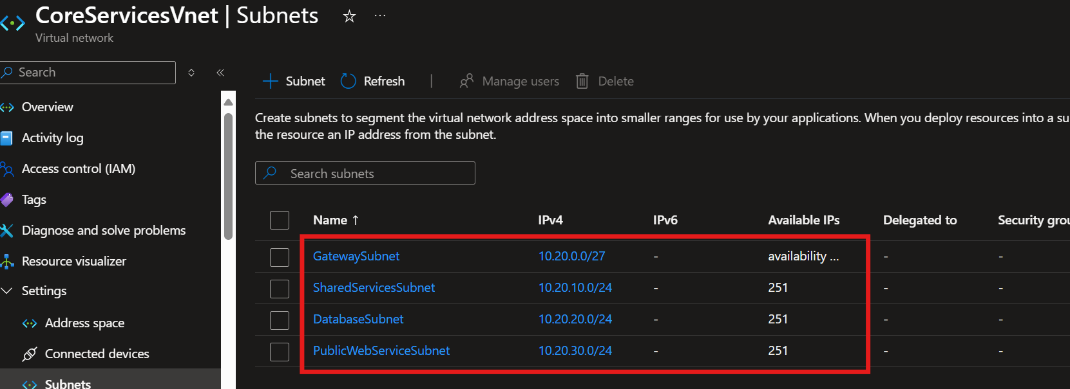
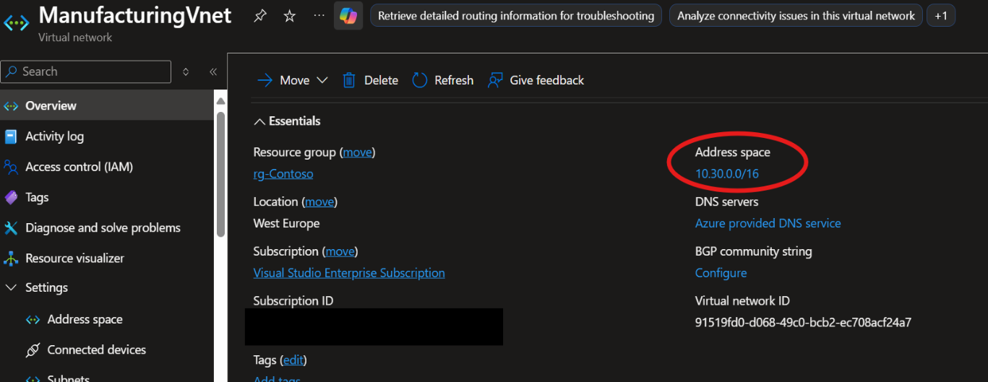
Figure2: CoreServicesVnet Subnets Overview
Figure 3: ManufacturingVnet Overview
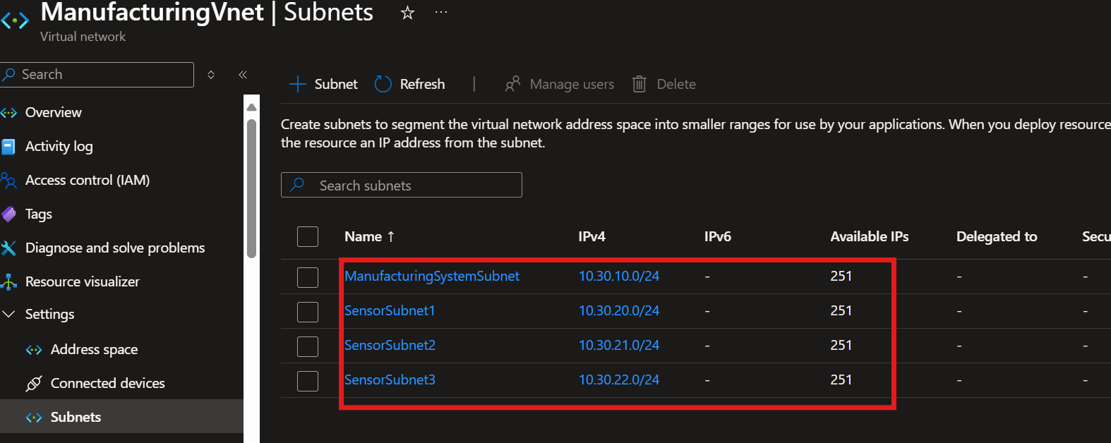
Figure 4: ManufacturingVnet Subnets Overview
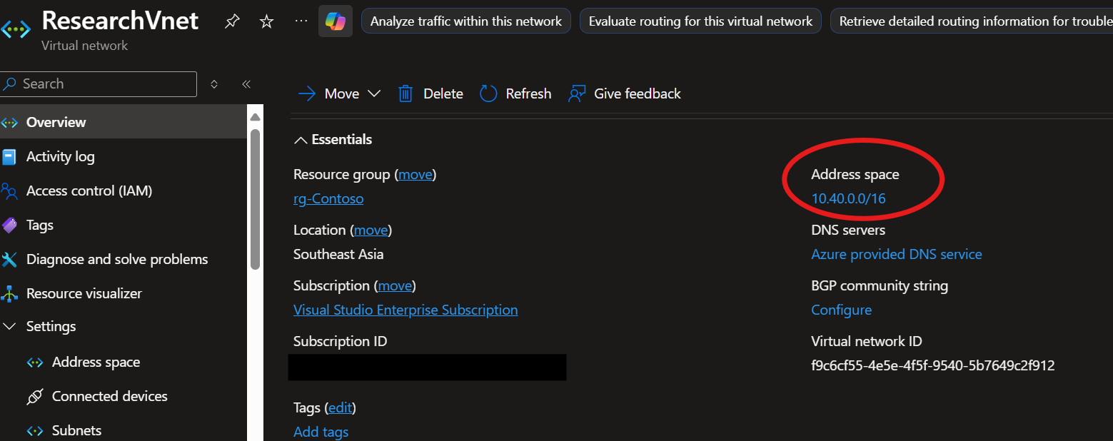

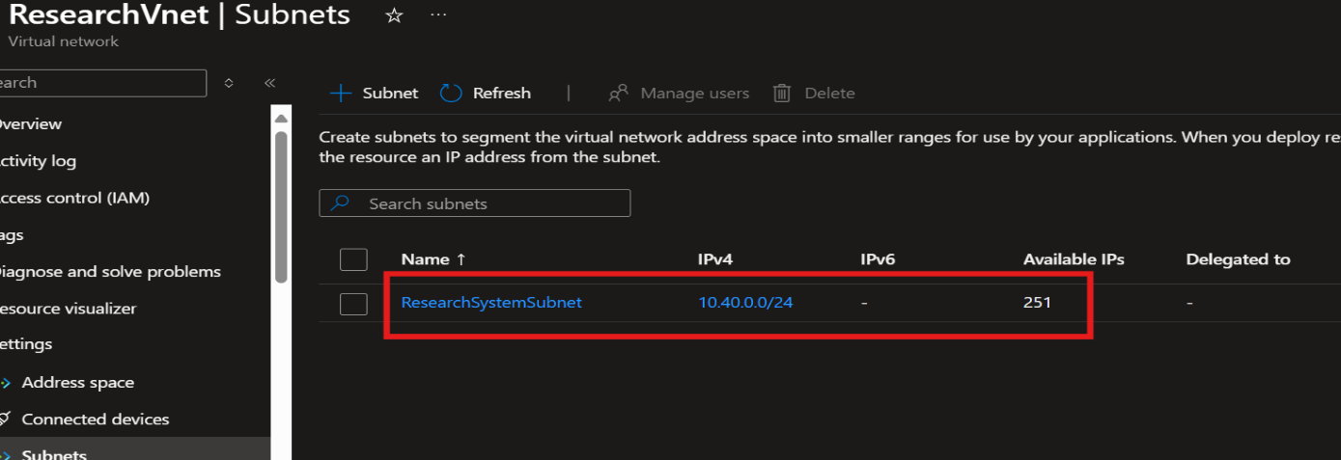
Figure 5: ResearchVnet Overview

Figure 6: ResearchVnet Subnets Overview

